Life Cycle Plan (LCP)

Lose4Good.org Database Driven Socially Connected Website

Team 08

Team Member Name | Primary Role | Secondary Role
Ali Alotaibi | Requirements Engineer | System Architect
Ankit Kalwar | Operational Concept Engineer | Project Manager
Arul Samuel | System Architect | Requirements Engineer
Manas Jog | Prototyper | Requirements Engineer
Monil Ashok Parikh | Quality Focal Point | System Architect
Omkar Yerunkar | Project Manager | Feasibility Analyst
Shalini Srinivas | Feasibility Analyst | Life cycle planner

12/09/2013

Version History
Date | Author | Version | Changes made | Rationale
09/26/13 | SS | 1.0 | Roles and Detailed skillset of the team members | Initial draft for Lose4Good project as a part of VC Package
10/13/13 | OY,MP | 2.0 | LCP document | Draft for Lose4Good project as a part of FC Package
10/22/13 | OY | 2.1 | COCOMO Estimation | Final draft for Lose4Good project as a part of FC Package
11/26/13 | OY | 3.0 | Iteration Plan | Initial draft for Draft DC Package
12/09/13 | OY | 3.1 | Iteration Plan | Final Draft for Draft DC Package

Table of Contents
Life Cycle Plan (LCP) i
Version History ii
Table of Contents iii
Table of Tables iv
Table of Figures v
1. Introduction 1
1.1 Purpose of the LCP 1
1.2 Status of the LCP 1
1.3 Assumptions 1
2. Milestones and Products 2
2.1 Overall Strategy 2
2.2 Project Deliverables 4
3. Responsibilities 6
3.1 Project-specific stakeholder’s responsibilities 6
3.2 Responsibilities by Phase 6
3.3 Skills 11
4. Approach 13
4.1 Monitoring and Control 13
4.2 Methods, Tools and Facilities 14
5. Resources 15
6. Iteration Plan 29
6.1 Plan 29

Table of Tables

Table 1. Artifacts Deliverables in Exploration Phase 4
Table 2. Artifact deliverable in Valuation Phase 4
Table 3. Artifacts Deliverables in Foundation Phase 5
Table 4. Artifacts Deliverables in Re-Baselined Foundation Phase 5
Table 5. Stakeholder's Responsibilities in each phase 6
Table 6. Skills of the team members 11
Table 7. Future Skills 12
Table 8. Methods, Tools and Facilities 14
Table 9. Module lists and SLOC of each module 15
Table 10. COCOMOII Scale Driver 16
Table 11. COCOMOII Cost Driver for Profile Management 17
Table 12. COCOMOII Cost Driver for Donation Management 19
Table 13. COCOMOII Cost Driver for Goal Creation and Tracking Management 21
Table 14. COCOMO II Cost Driver for Reward Management 23
Table 15. COCOMO II Cost Driver for Marketing Management 25
Table 16. Construction iteration capabilities to be implemented 29

Table of Figures
Figure 1. Scale Factors 16
Figure 1. Profile management 18
Figure 2. Donation management 20
Figure 3. Goal Creation and Tracking Management 22
Figure 4. Reward Management 24
Figure 5. Marketing Management 26
Figure 6. Result 27
Figure 7. Core Module Estimation Result 28

    - Introduction

Purpose of the LCP
The purpose of LCP is to provide with the basic plan related to steps associated with the activities and working of the team for the software development process. LCP provides the detailed description of the management of the project in concise and precise manner.

Status of the LCP
The status of the LCP is currently at the Foundation Package version number 3.0. This is the version that will be delivered to the client. No major changes are being done as we are developing the same from the scratch and are in the valuation phase.

Assumptions
  - The duration of the project is 24 weeks, which are 12 weeks in fall 2013 and 12 weeks in spring 2014.
  - The development team consists of 7 members wherein 4 members will continue with the project for 24 weeks and rest 3 are unsure for last 12 weeks. Most probably we will get proper replacements based on the skill set for the rest 3 members during the working of the project for the remaining 12 weeks.
  - ICSM- Electronic Process Guide provided on the course website is being used as a set of guidelines to assist the development of the software process.

    - Milestones and Products

Overall Strategy

Lose4Good.org is following Architected Agile process because there are Non-Development Items or Web services which make less that 30% of the most of the core capabilities.

Exploration phase
Duration: 09/11/13- 09/27/13
Concept: In this phase the team identifies the project operational concept, system and software requirement, system and software architecture, and life-cycle plan. These phases prioritize the capabilities, conduct investment and feasibility analysis, and implement the software prototype.
Deliverables: Valuation Commitment Package, Client Interaction Report, Bi-weekly Project Plan and Report, Weekly Effort Report.
Milestone: Valuation Commitment Review
Strategy: One Incremental Commitment Cycle

Valuation phase
Duration: 09/28/13- 10/16/13
Concept: In this phase the team identifies the objectives, constraints and priorities, develop operational concept, perform win-win negotiations, prototyping, and explore alternatives thus providing project feasibility evidence. Also the team assesses and develops plans to mitigate risks, plan and manage project, verify and validate products using defect tracking system and define quality and configuration policy.
Deliverables: Foundation Commitment Package, Bi-weekly Project Report and Plan, Weekly Effort Report.
Milestone: Foundation Commitment Review
Strategy: One Incremental Commitment Cycle

Foundation phase
Duration: 10/19/13- 12/02/13
Concept: In this phase the team assesses the project status, plan and manage project, develops the prototype and manage the quality of the project.
Deliverables: Draft Development Commitment Package, Bi-weekly Project Report and Plan, Weekly Effort Report.
Milestone: Development Commitment Review
Strategy: One Incremental Commitment Cycle

Re-Baselined Foundation phase
Duration: 01/13/14- 02/10/14
Concept: In this phase the development team will rebaseline the project status and prepare for development phase. Also test plans will be put forward along with the detailed project plan.
Deliverables: Draft Re-Baselined Development Commitment Package, Bi-weekly Project Report and Plan, Weekly Effort Report.
Milestone: Re-Baselined Development Commitment Review
Strategy: One Incremental Commitment Cycle

Project Deliverables

Exploration Phase
- Artifacts Deliverables in Exploration Phase
Artifact | Due date | Format | Medium
Client Interaction Report | 09/20/2013 | .doc, .pdf | Soft copy
Valuation Commitment Package  - Operational Concept Description (OCD) Early Section  - Life Cycle Plan (LCP) Early Section  - Feasibility Evidence Description (FED) Early Section | 09/27/2013 | .doc, .pdf | Soft copy
Microsoft Project Plan | Bi-weekly Monday | .mpp, .pdf | Soft copy
Progress Report | Bi-weekly Monday | .xls | Soft copy
Risk Analysis | Bi-weekly Monday | Text | Part of Progress Report

Valuation Phase
- Artifact deliverable in Valuation Phase
Artifact | Due date | Format | Medium
Foundation Commitment Package  - Operational Concept Description (OCD)  - Life Cycle Plan (LCP)  - Feasibility Evidence Description (FED)  - System and Software Requirements Definition(SSRD)  - Prototype Report(PRO) | 10/16/2013 | .doc,.pdf | Soft copy
Microsoft Project Plan | Bi-weekly Monday | .mpp,.pdf | Soft copy
Progress Report | Bi-weekly Monday | .xls | Soft copy
Effort Report | Every Monday | Text | ER system
Risk Analysis | Bi-weekly Monday | Text | Part of Progress Report

Foundation Phase
- Artifacts Deliverables in Foundation Phase

Artifact | Due date | Format | Medium
Development Commitment Package  - Operational Concept Description (OCD)  - Life Cycle Plan (LCP)  - Feasibility Evidence Description (FED)  - System and Software Requirements Definition(SSRD)  - Test Plan and Cases (TPC)  - Transition Plan (TP) | 12/02/2013 | .doc, .pdf | Soft copy
Microsoft Project Plan | Bi-weekly Monday | .mpp, .pdf | Soft copy
Progress Report | Bi-weekly Monday | .xls | Soft copy
Risk Analysis | Bi-weekly Monday | Text | Part of Progress Report
Effort Report | Every Monday | Text | ER system

Re-Baselined Foundation Phase

- Artifacts Deliverables in Re-Baselined Foundation Phase

Artifact | Due date | Format | Medium
Draft Re-Baselined Development Commitment Package | 01/10/2014 | .doc, .pdf | Soft copy
Microsoft Project Plan | Bi-weekly Monday | .mpp, .pdf | Soft copy
Progress Report | Bi-weekly Monday | .xls | Soft copy
Risk Analysis | Bi-weekly Monday | Text | Part of Progress Report
Effort Report | Every Monday | Text | ER system

    - Responsibilities

Project-specific stakeholder’s responsibilities
The client is Mr. Paul Charron, Senior Manager at 20th Century Fox. The users of the system are all the weight losers, their relatives i.e. personal sponsors, business organizations i.e. business sponsors and the charity organizations. Mr. Paul Charron is the project-specific stakeholder. Since the system has to be developed from the scratch, Mr. Charron is providing us with the detailed requirements of the system and also his specific requirements for the Version 1.0 of the system.

Responsibilities by Phase
The primary and secondary roles of each team member are summarized below. These roles are categorized based on the primary role and secondary roles that are being took up by the team members.
- Stakeholder's Responsibilities in each phase
Team Member / Role | Primary / Secondary Responsibility
Team Member / Role | Exploration | Valuation | Foundations | Development- Construction Iteration | Development- Transition Iteration
Omkar Yerunkar  Primary: Project Manager  Secondary: Feasibility Analyst. | Primary Responsibility  - Plan the project  -Analyze Proposed System.  Secondary Responsibility  -Identify risks  -Manage Bugzilla Repository | Primary Responsibility  -Record Bi-weekly project progress  -Detailed project plan.  -Co-ordinate team meetings  Secondary Responsibility  -Manage Bugzilla Repository  -Assess and evaluate NDI/NCS components.  -Assess and plan to mitigate risks.  -Access feasibility evidence. | Primary Responsibility  -Record Bi-weekly project progress  -Detailed project plan  -Planning, Monitoring and Control.  Secondary Responsibility  -Manage Bugzilla repository  -Acquire NDI/NCS components.  -Identify most appropriate process.  -Provide conclusions and recommendations.  -Provide feasibility evidence for architected agile project | Primary Responsibility  -Record Bi-weekly project progress  -Detailed project plan  -Planning, Monitoring and Control.  - Part of the implementation team(Coding)  - System, unit, integration testing  Secondary Responsibility  -Manage Bugzilla repository  -Identify most appropriate process. | Primary Responsibility  -Record Bi-weekly project progress  -Detailed project plan  -Planning, Monitoring and Control.  - Part of the implementation team(Coding)  - Launch the system with proper transition plan  Secondary Responsibility  -Manage Bugzilla repository  -Identify most appropriate process.
Ankit Kalwar  Primary: Operational Concept Engineer  Secondary: Project Manager | Primary Responsibility  -System Conceptualization  -Assess operational Concept.  -Identify Shared Vision  Secondary Responsibility  -Interact with Client  -Manage Bugzilla repository | Primary Responsibility  -Establish new operational concept.  -Explore alternatives.  -Analyze Current System.  Secondary Responsibility  -Develop operational concept  -Manage Bugzilla repository | Primary Responsibility  -System Conceptualization  Secondary Responsibility  -Interact with Client  -Manage Bugzilla repository | NA | NA
Arul Rajkumar  Primary: System Architect.  Secondary: Requirements Engineer | Primary Responsibility  -Analyze Proposed System.  -Provide system architecture  -Provide feasibility evidence for Architected Agile  Secondary Responsibility  -Facilitate win-win negotiations | Primary Responsibility  -Analyze Proposed System.  -Provide system architecture  -Provide feasibility evidence for Architected Agile  -Assess Proposed System.  Secondary Responsibility  -Tailoring win conditions | Primary Responsibility  -Analyze Proposed System.  -Provide system architecture  -Provide feasibility evidence for Architected Agile  -Assess Proposed System.  Secondary Responsibility  -Tailoring win conditions | Primary Responsibility  -Analyze Proposed System.  -Assess Proposed System.  - Part of the implementation team(Coding)  - System, unit, integration testing  Secondary Responsibility  -Tailoring user requirements | Primary Responsibility  -Analyze Proposed System.  -Assess Proposed System.  - Part of the implementation team(Coding)  - Launch the system with proper transition plan  Secondary Responsibility  -Support Maintainer, User, Client
Manas Jog  Primary: Prototyper  Secondary: Requirements Engineer. | Primary Responsibility  -Analyze and prioritize capabilities to prototype.  -Update website  Secondary Responsibility  -Facilitate win-win negotiations | Primary Responsibility  -Assess prototype components.  -Update website  Secondary Responsibility  -Capture MMF’s.  -Score Win-Win condition.  -Establish New Operational Concept | Primary Responsibility  -Develop prototype.  -Establish new operation concept.  -Prepare development components.  -Tailor Components.  -Update website  Secondary Responsibility  -Capture progress of Win-Win condition. | NA | NA
Monil Parikh  Primary: System Architect  Secondary: Quality focal Point | Primary Responsibility  -Analyze Proposed System.  -Provide system architecture  -Provide feasibility evidence for Architected Agile  Secondary responsibility  -Assess quality of the proposed system | Primary Responsibility  -Analyze Proposed System.  -Provide system architecture  -Provide feasibility evidence for Architected Agile  -Assess Proposed System.  Secondary Responsibility  -Assess Quality management strategy. | Primary Responsibility  -Analyze Proposed System.  -Provide system architecture  -Provide feasibility evidence for Architected Agile  -Assess Proposed System.  Secondary Responsibility  -Identify configuration management.  -Identify quality management strategy.  -Construct Traceability Matrix. | NA | NA
Shalini Srinivas  Primary: Feasibility Analyst  Secondary: IV & V, Life cycle planner. | Primary Responsibility  -Analyze Proposed System.  -Identify risks  Secondary Responsibility  -Identify milestones and products | Primary Responsibility  -Analyze business case.  -Assess and plan to mitigate risks.  -Assess feasibility evidence.  -Explore alternatives.  Secondary Responsibility  -Assess development Iteration.  -Assign roles and responsibilities.  -Estimate effort, cost and schedule using tools like COCOMO-II | Primary Responsibility  -Identify most appropriate process.  -Provide conclusions and recommendations.  -Provide feasibility evidence for architected agile project .  Secondary Responsibility  -Verify and validate work products.  -Identify Milestones and products.  -Identify LC management approach.  -Develop support & transition plan.  -Detailed project plan.  _identify development iteration.  -Provide process feasibility evidence. | NA | `NA
Name: Ali  Primary: Requirements Engineer.  Secondary: System Architect | Primary Responsibility  -Analyze Current/Proposed System.  Secondary Responsibility  -Provide system architecture  -Provide feasibility evidence for Architected Agile | Primary Responsibility  -Capture MMF’s.  -Score Win-Win condition.  -Establish New Operational Concept  Secondary Responsibility  --Assess and evaluate NDI components.  -Assess NDI interoperability  -Provide feasibility evidence of NDI components.  -Provide feasibility evidence for architecture agile project. | Primary Responsibility  -Capture progress of Win-Win condition.  Secondary Responsibility  -Assess System Architecture.  -Define technology dependent architecture.  -Specify Architecture styles, patterns and framework. | Primary Responsibility  -Analyze Proposed System.  -Assess Proposed System.  - Part of the implementation team(Coding)  - System, unit, integration testing  Secondary Responsibility  -Tailoring user requirements | Primary Responsibility  -Analyze Proposed System.  -Assess Proposed System.  - Part of the implementation team(Coding)  - Launch the system with proper transition plan  Secondary Responsibility  -Support Maintainer, User, Client
Name: Paul Charron  (Client) | -Specify the requirements of the system  - win-win negotiations | -Tailor requirements based on the win-win negotiations  -Define shortfalls | -Provide feedback based on the prototype  -Define prototype shortfalls  -Define desired system and the requirements to achieve it  -Provide changed requirements | -Provide feedback based on the current system  --Provide changed requirements | -Provide feedback based on the current system  --Provide changed requirements  -Receive training for new system, provide training to the users

Skills
- Skills of the team members

Team member | Role | Skills
Ali Alotaibi  (577a, 577b) | Requirements Engineer  Architect  Implementer | UML, Design Patterns, Risk Assessment, Critical thinking, Java, MySQL
Ankit Kalwar  (577a) | Operational Concept Engineer  Project Manager | Analysis and Assessment of operational concept, Project management, Win-Win Negotiation, PHP, MySQL,Java
Arul Samuel  (577a, 577b) | Architect  Requirement Engineer  Implementer | UML, Design Patterns, Python, MySQL, AJAX, JavaScript, RSA
Manas Jog  (577a) | Prototyper  Requirements Engineer | Python, MySQL, AJAX, JavaScript, RSA, HTML5
Monil Parikh  (577a, 577b) | Architect  Quality Focal Point  Implementer | UML, Design Patterns, UML, Design Patterns, Python
Omkar Yerunkar  (577a, 577b) | Project Manager  Feasibility Analyst  Implementer | Project management, Win-Win Negotiation, COCOMO, Feasibility and Risk Analysis, MySQL, Java
Shalini Srinivas  (577a) | Feasibility Analyst  Life Cycle Planner  IV&V | Feasibility and Risk Analysis, Project Coordination, Cost and Benefit Analysis, MS Project, COCOMO, Python

- Future Skills

Team member | Role | Skills (required)
Future team member  (577b) | Implementer | Python-Django, MySQL, JavaScript
Future team member  (577b) | Tester | Unit testing, integration testing, coding and debugging skills , Python- Django, JavaScript
Future team member  (Client side at the end of semester) | Maintainer | Python- Django ,MySQL, Administrative skills, Critical thinking, debugging skills

    - Approach

Monitoring and Control
The following will be the tools and documentation used by Team 08 for monitoring and control of the project:
- Progress Report- Bi-weeks progress that keeps a track of risks and COTS used.
- Project Plan-Keeps a track of deadlines, stakeholders and documentation briefing each section of the project.
- Bugzilla System- Used for defect tracking. Also used to keep track of the artifacts being worked on and to assign tasks and activities to the team members.
- Effort Report- Documentation representing the effort taken in minutes by each member.

Closed Loop Feedback Control
The project manager and IIV & V member processes all the documents to the Dropbox folder before submission. The documents are shared in dropbox so that it provides access of all the documents to any of the team member if he wants to review any document.

Reviews
- Bugzilla System
- Weekly stakeholder meetings
- Unplanned individual reviews
- IIV&V reviews
- Effort Report

Methods, Tools and Facilities
- Methods, Tools and Facilities
Tools | Usage | Provider
MS Project | Assesses and mitigates risks in the system development life cycle | USC License
Balsamiq | Provides examples for user interface and system functionality, is helpful in the development of prototype | Balsamiq Studios
Pyscripter | Creates a framework and distribution system for reusable Python components | Open source
Visual Paradigm | UML case tool used for modeling UML diagrams | USC License
COINCOMO | Estimation of cost and effort | USC License
Bugzilla | Assigning tasks and activities to the team members | USC License
Team Viewer | To undertake weekly meetings | Team viewer GmbH
Curl | Directly performing HTTP transaction for testing purpose | Open Source
Microsoft Word | Used for documenting deliverables (LCP, FED, PRO, SSAD, OCD) | Microsoft

Resources

- Estimated CSCI577a Effort : 7 team members at 12 hrs/week for 12 weeks
- Total 577a estimated effort: 1008 hours
- Budget information-$3000
- Project duration-24 weeks( Fall 2013)
- Component modules:-
1. Profile Management
2.Donation Management
3.Goal Creation & Tracking Management
4.Marketing Management
5.Reward Management
- Programming language used: Python, JavaScript, HTML5

- Module lists and SLOC of each module

No. | Module Name | Brief Description | SLOC | REVL
1 | Profile Management | Enables user to create profile and manage it. | 350 | 0%
2 | Donation management | Involves transaction between sponsors and charity via PayPal | 1100 | 0%
3 | Goal Creation And Tracking | Enables user to track his/her goals on a weekly basis. | 500 | 0%
4 | Reward Management  (Evolutionary) | Enables user to take benefits of the assigned rewards after completion of goals. | 350 | 0%
5 | Marketing Management  (Evolutionary) | Enables sponsors to advertise through lose4good.org | 700 | 0%

- COCOMOII Scale Driver
Scale Driver | Value | Rationale
PREC | LO | The system is being built from the scratch and the team members haven’t done any similar kind of project before.
FLEX | HI | The client has the idea and the some general goals and Requirements and open for suggestions. Interface and schedule flexibility.
RESL | NOM | Considerable level of uncertainty with 3 critical risk items.
TEAM | NOM | Basically co-operative interactions, basic consistency and little experience in working as a team.
PMAT | NOM | ICSM guidelines and principles followed.

- Scale Factors

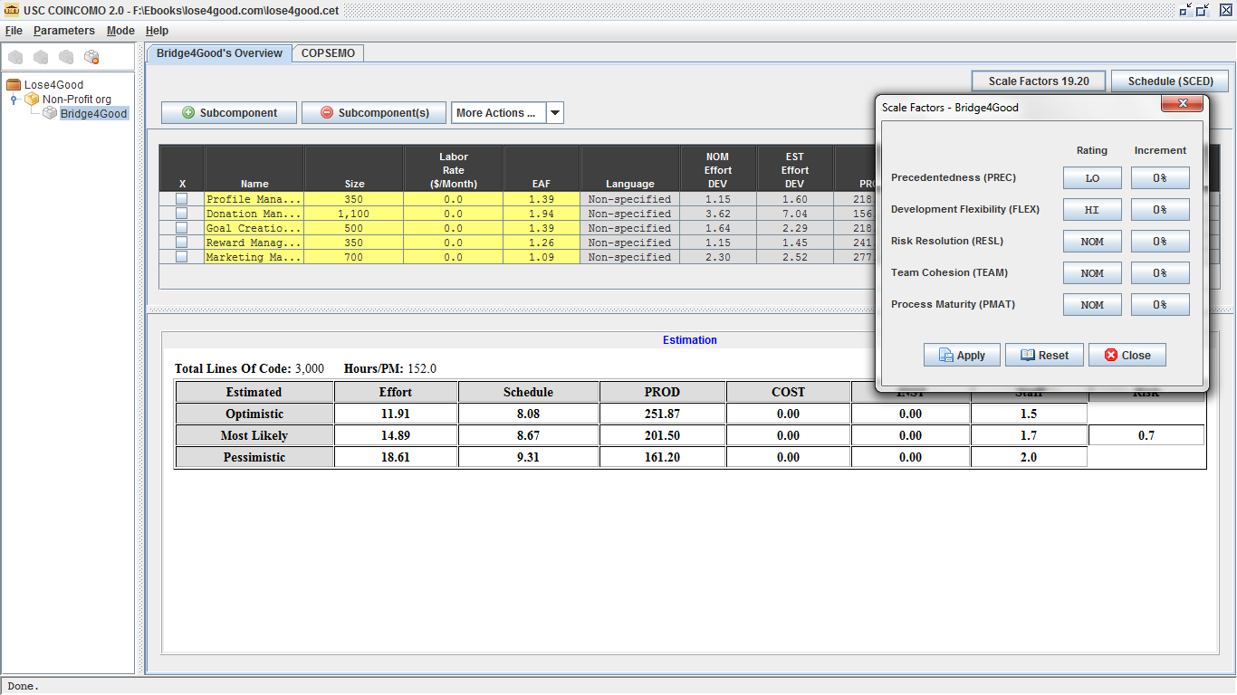

- COCOMOII Cost Driver for Profile Management
Cost Driver | Value | Rationale
RELY | LO | Failure will lead to losses which will be easily recoverable.
DATA | NOM | Database will be required to store user information. 10≤D/P<100
CPLX | NOM | Simple use of widget set, simple nesting, status checking, complex queries.
RUSE | NOM | The client is planning to reuse the module often in very similar system applications. i.e. across project
DOCU | NOM | Right-sized documentation required.
TIME | NOM | The system consumes nominal time and the required resources.
STOR | HI | Requires a large amount of storage for increasing no. of users profiles.
PVOL | LO | Major change needs to be done in 12 months for developing new application of the project.
ACAP | NOM | Analysts have basic knowledge and nominal experience.
PCAP | LO | Many members have low experience.
PCON | VLO | All the team members will not be available throughout the project.
APEX | LO | All the team members have less application experience.
PLEX | LO | All the team members have less platform experience.
LTEX | NOM | Intermediate programming language and tool experience.
TOOL | NOM | Moderately integrated tools being used.
SITE | HI | The client and members are in the same city.
- Profile management
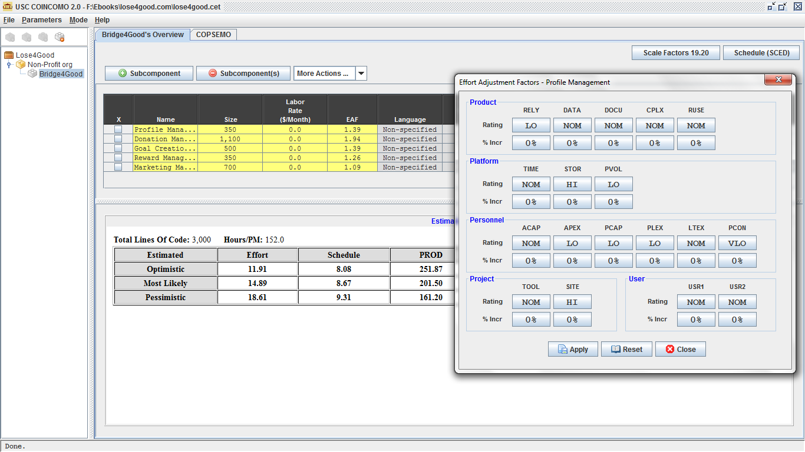

- COCOMOII Cost Driver for Donation Management

Cost Driver | Value | Rationale
RELY | HI | Failure will lead to high financial loss involving payment transactions.
DATA | NOM | Database will be required to store user transaction information.10≤D/P≤100
CPLX | HI | Highly nested structured programming required, interpolation, I/O operations at physical level, triggers for data stream and widget extension.
RUSE | NOM | The client is planning to reuse the module often in very similar system applications. i.e. across project
DOCU | NOM | Right-sized documentation required.
TIME | NOM | The system module will consume nominal time and the required resources.
STOR | HI | Requires a large amount of storage for increasing no. of transaction of user profiles.
PVOL | LO | Major change needs to be done in 12 months for developing new application of the project.
ACAP | NOM | Analysts have basic knowledge and nominal experience.
PCAP | LO | Many members have low experience.
PCON | VLO | All the team members will not be available throughout the project.
APEX | LO | All the team members have less application experience.
PLEX | LO | All the team members have less platform experience.
LTEX | NOM | Intermediate programming language and tool experience.
TOOL | NOM | Moderately integrated tools being used.
SITE | HI | The client and members are in the same city.

- Donation management
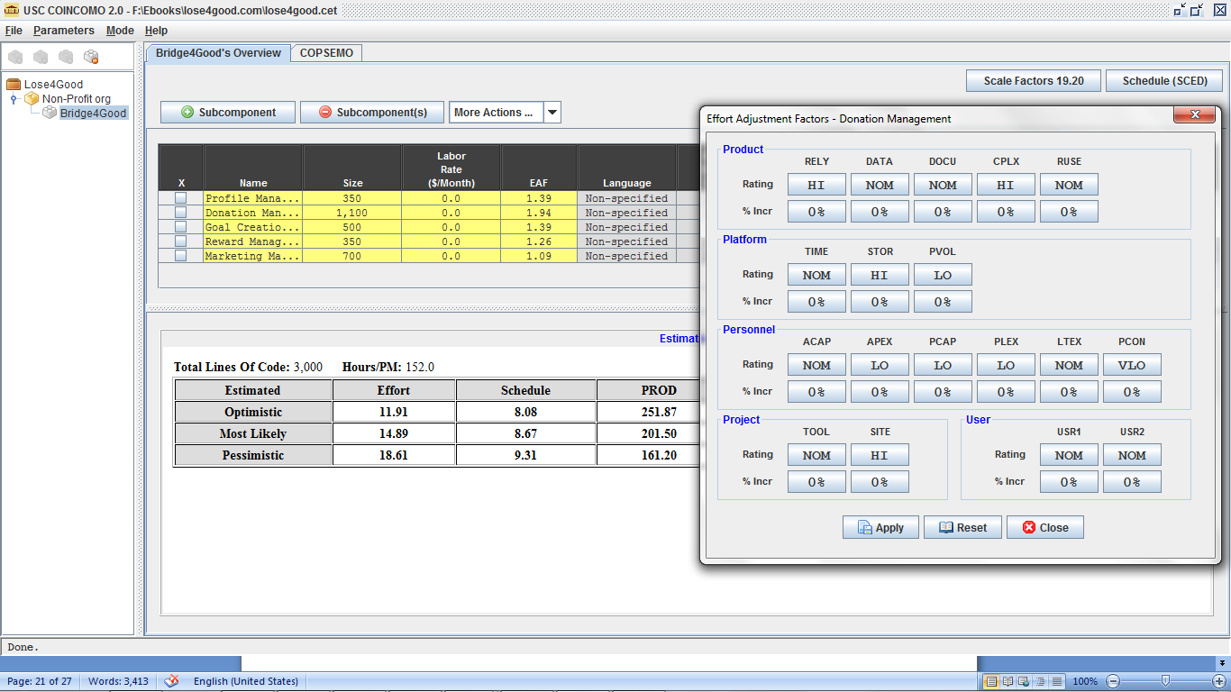

- COCOMOII Cost Driver for Goal Creation and Tracking Management

Cost Driver | Value | Rationale
RELY | LO | Failure will lead to losses which will be easily recoverable.
DATA | NOM | Database will be required to store user information.10≤D/P≤100
CPLX | NOM | Status checking , error processing, callbacks and message passing done with basic matrix operations.
RUSE | NOM | The client is planning to reuse the module often in very similar system applications. i.e. across project
DOCU | NOM | Right-sized documentation required.
TIME | NOM | The system consumes nominal time and the required resources.
STOR | HI | Requires a large amount of storage for goal creation and tracking which is associated with user profile.
PVOL | LO | Major change needs to be done in 12 months for developing new application of the project.
ACAP | NOM | Analysts have basic knowledge and nominal experience.
PCAP | LO | Many members have low experience.
PCON | VLO | All the team members will not be available throughout the project.
APEX | LO | All the team members have less application experience.
PLEX | LO | All the team members have less platform experience.
LTEX | NOM | Intermediate programming language and tool experience.
TOOL | NOM | Moderately integrated tools being used.
SITE | HI | The client and members are in the same city.

- Goal Creation and Tracking Management
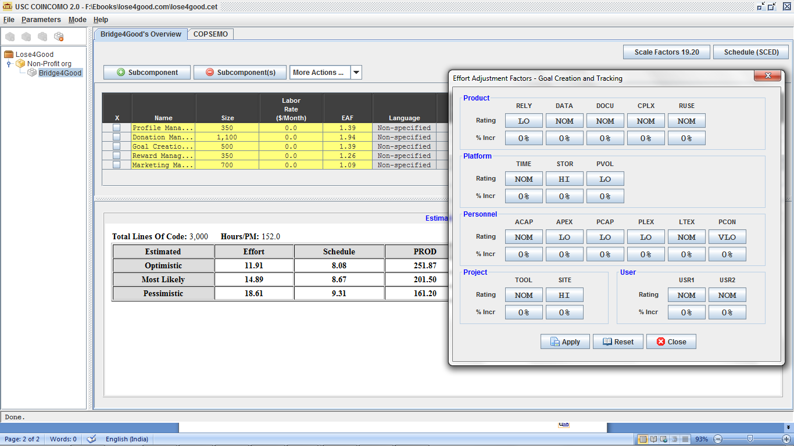

- COCOMO II Cost Driver for Reward Management

Cost Driver | Value | Rationale
RELY | LO | Failure will lead to losses which will be easily recoverable.
DATA | NOM | Database will be required to store charity, user and sponsor information. 10≤D/P≤100
CPLX | NOM | Message passing, simple nesting required.
RUSE | LO | This module will hardly be used for another application.
DOCU | NOM | Right-sized documentation required.
TIME | NOM | The system consumes nominal time and the required resources.
STOR | NOM | Requires a moderate amount of storage for reward managing associated with the no. of sponsors and charities.
PVOL | LO | Major change needs to be done in 12 months for developing new application of the project.
ACAP | NOM | Analysts have basic knowledge and nominal experience.
PCAP | LO | Many members have low experience.
PCON | VLO | All the team members will not be available throughout the project.
APEX | LO | All the team members have less application experience.
PLEX | LO | All the team members have less platform experience.
LTEX | NOM | Intermediate programming language and tool experience.
TOOL | NOM | Moderately integrated tools being used.
SITE | HI | The client and members are in the same city.

- Reward Management

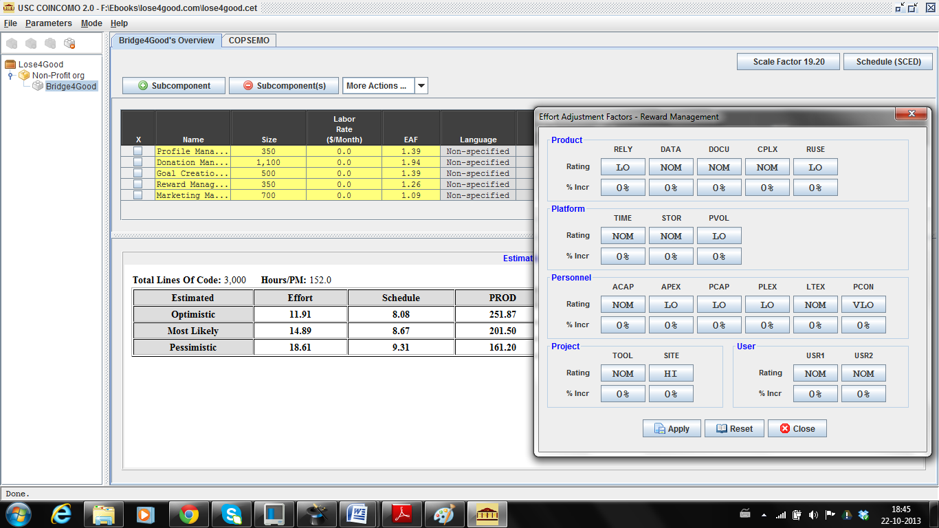

- COCOMO II Cost Driver for Marketing Management

Cost Driver | Value | Rationale
RELY | LO | Failure will lead to losses associated with advertisements which will be easily recoverable.
DATA | NOM | 10≤D/P≤100
CPLX | LO | Use of simple GUI builders and moderate level expressions being used for the module.
RUSE | LO | This module will hardly be used in another applications.
DOCU | NOM | Right-sized documentation required.
TIME | NOM | The system consumes nominal time and the required resources.
STOR | NOM | Requires a moderate amount of storage for reward managing associated with the sponsors.
PVOL | LO | Major change needs to be done in 12 months for developing new application of the project.
ACAP | NOM | Analysts have basic knowledge and nominal experience.
PCAP | LO | Many members have low experience.
PCON | VLO | All the team members will not be available throughout the project.
APEX | LO | All the team members have less application experience.
PLEX | LO | All the team members have less platform experience.
LTEX | NOM | Intermediate programming language and tool experience.
TOOL | NOM | Moderately integrated tools being used.
SITE | HI | The client and members are in the same city.

- Marketing Management

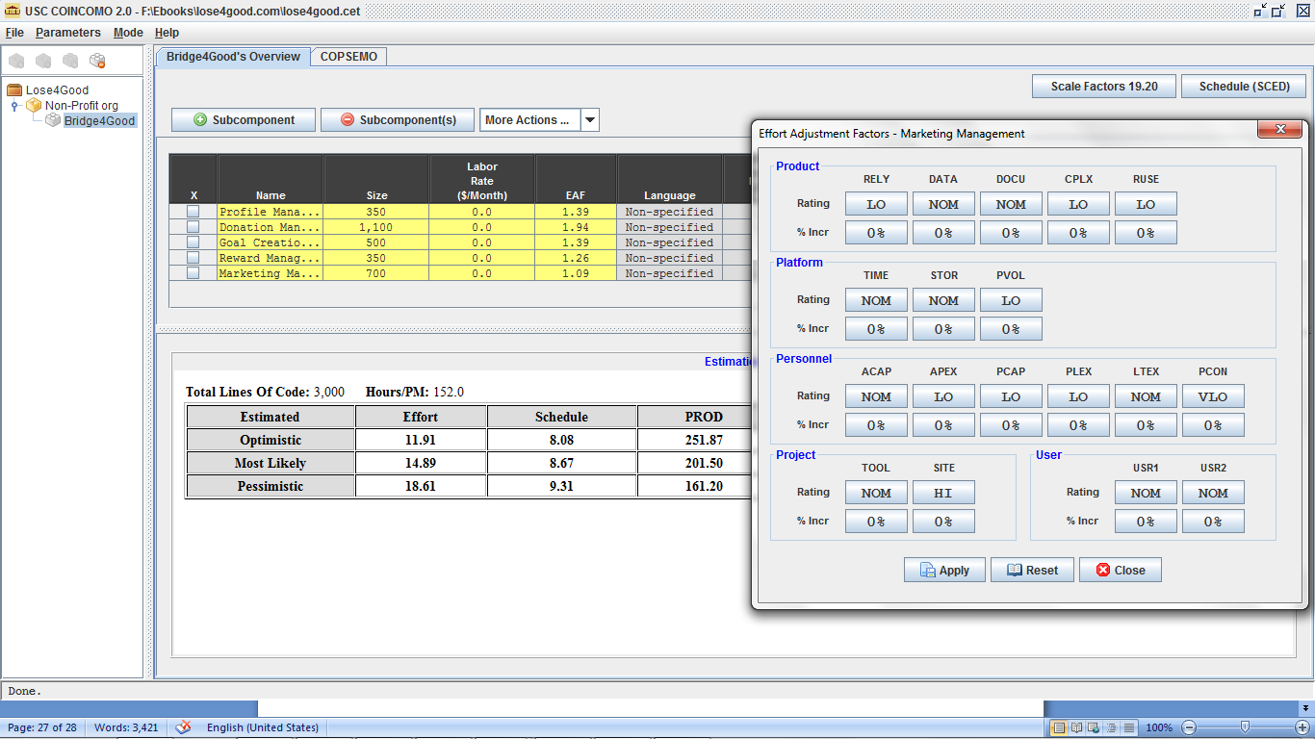

- Result
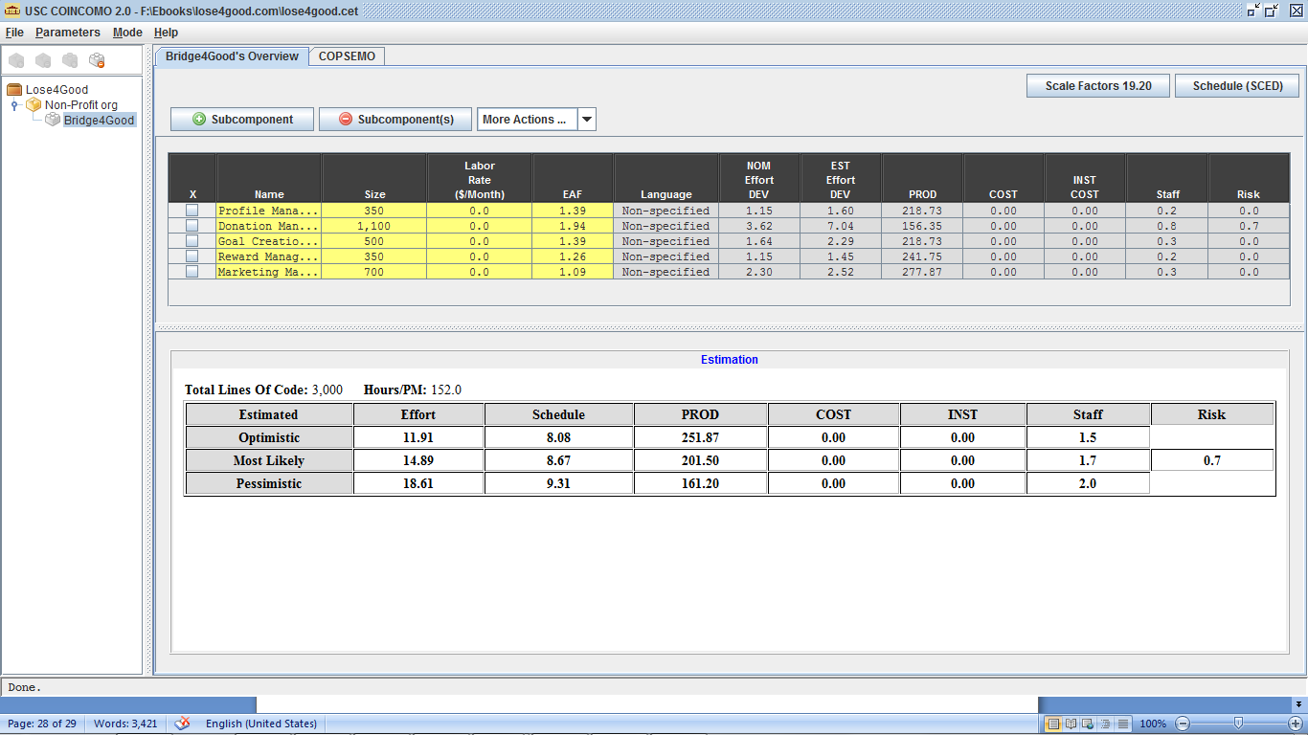

The form of schedule our project uses is the Independent Variable (SAIV) strategy; 24–week
schedule drives development of a set of top priority core capabilities. Therefore, the estimates
show the effort required for the project.

According to COCOMO II Estimates for CSCI577, one team member effort = 1.67 COCOMO II
person months. The pessimistic effort from the COCOMO estimation above is 18.61, so the total team members need for this project = 18.61/1.67 = 11.14

Hence we decided to implement the core modules required for the project. i.e. Profile, Donation and Goal Creation And Tracking Management modules. Their estimation is given as follows:

- Core Module Estimation Result

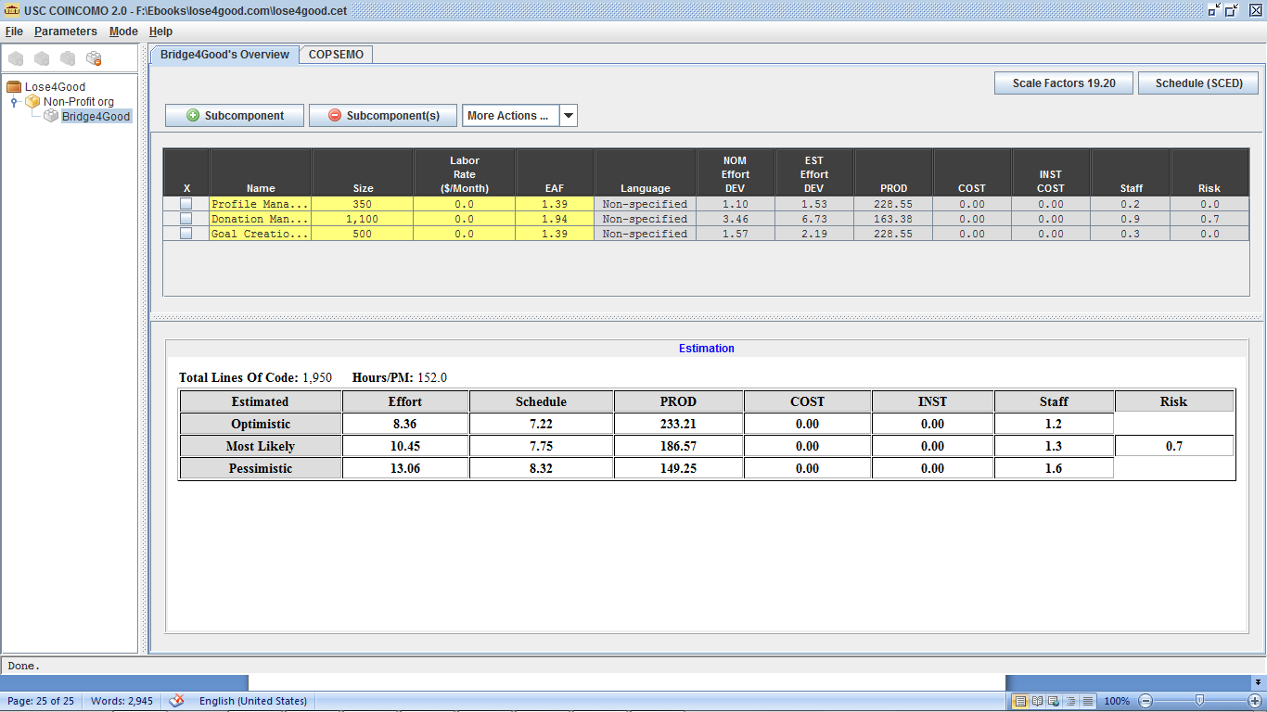

According to COCOMO II Estimates for CSCI577, one team member effort = 1.67 COCOMO II person months. The most likely effort from the COCOMO estimation above is 10.45, so the total team members need for this project = 10.45/1.67 = 6.25

Thus it is possible for us to complete the core feature implementation in 24 weeks.

Iteration Plan

Plan
The first iteration of the development process focuses on creation of the profile management, donation management and goal creation and tracking management modules to a large extent. This will allow the user to use the website in order to create profile, update it and its related functionalities along with partly resolved donation and goal creation and tracking management module functionalities. The Re-Baselined Development Commitment Review and the Core Capability Drivethrough are the milestones which will be addressed during this iteration.

Capabilities to be implemented
- Construction iteration capabilities to be implemented
ID | Capability | Description | Priority Level | Iteration
OC-1 | Login using Facebook | Login through facebook would be achieved. | Must Have | 1
OC-2 | Delete Goal | Goal would be deleted if there is no sponsor. | Must Have | 2
OC-3 | Track Goal | All details of the weight loser will be tracked. | Would Like | 2
OC-4 | Monitor Payment | Payments to the charity will be done after verification. | Must Have | 2
OC-5 | Achieve Goal | Completion of a goal. | Would Like | 1
OC-6 | Create Goal | Creation of a new goal. | Must Have | 1
OC-7 | Respond to a sponsorship request | Accept payment from sponsor with specific details. | Must Have | 1
OC-8 | Invite Sponsor | Invitation to the sponsor will be sent through email. | Would Like | 1
OC-9 | Add Charity Organization | Adding a charity from existing list or a new one. | Would Like | 1
OC-10 | Update Weight | Update weight and publish benchmark. | Must Have | 1
OC-11 | Login | Login via email address and password. | Must Have | 1
OC-12 | Register | User will be registered by assigning him an account with his credentials. | Must Have | 1

Capabilities to be tested
ID | Capability | Description | Priority Level | Iteration
OC-1 | Login using Facebook | Login through facebook would be achieved. | Must Have | 1
OC-5 | Achieve Goal | Completion of a goal. | Would Like | 1
OC-6 | Create Goal | Creation of a new goal. | Must Have | 1
OC-7 | Respond to a sponsorship request | Accept payment from sponsor with specific details. | Must Have | 1
OC-8 | Invite Sponsor | Invitation to the sponsor will be sent through email. | Would Like | 1
OC-9 | Add Charity Organization | Adding a charity from existing list or a new one. | Would Like | 1
OC-10 | Update Weight | Update weight and publish benchmark. | Must Have | 1
OC-11 | Login | Login via email address and password. | Must Have | 1
OC-12 | Register | User will be registered by assigning him an account with his credentials. | Must Have | 1

Capabilities not to be tested

ID | Capability | Description
OC-2 | Delete Goal | Delete Goal is independent and hence can be done in next iteration.
OC-3 | Track Goal | Focus is on high value items and hence pushed to next iteration
OC-4 | Monitor Payment | Payment process is involved and will require some processing from this iteration.

